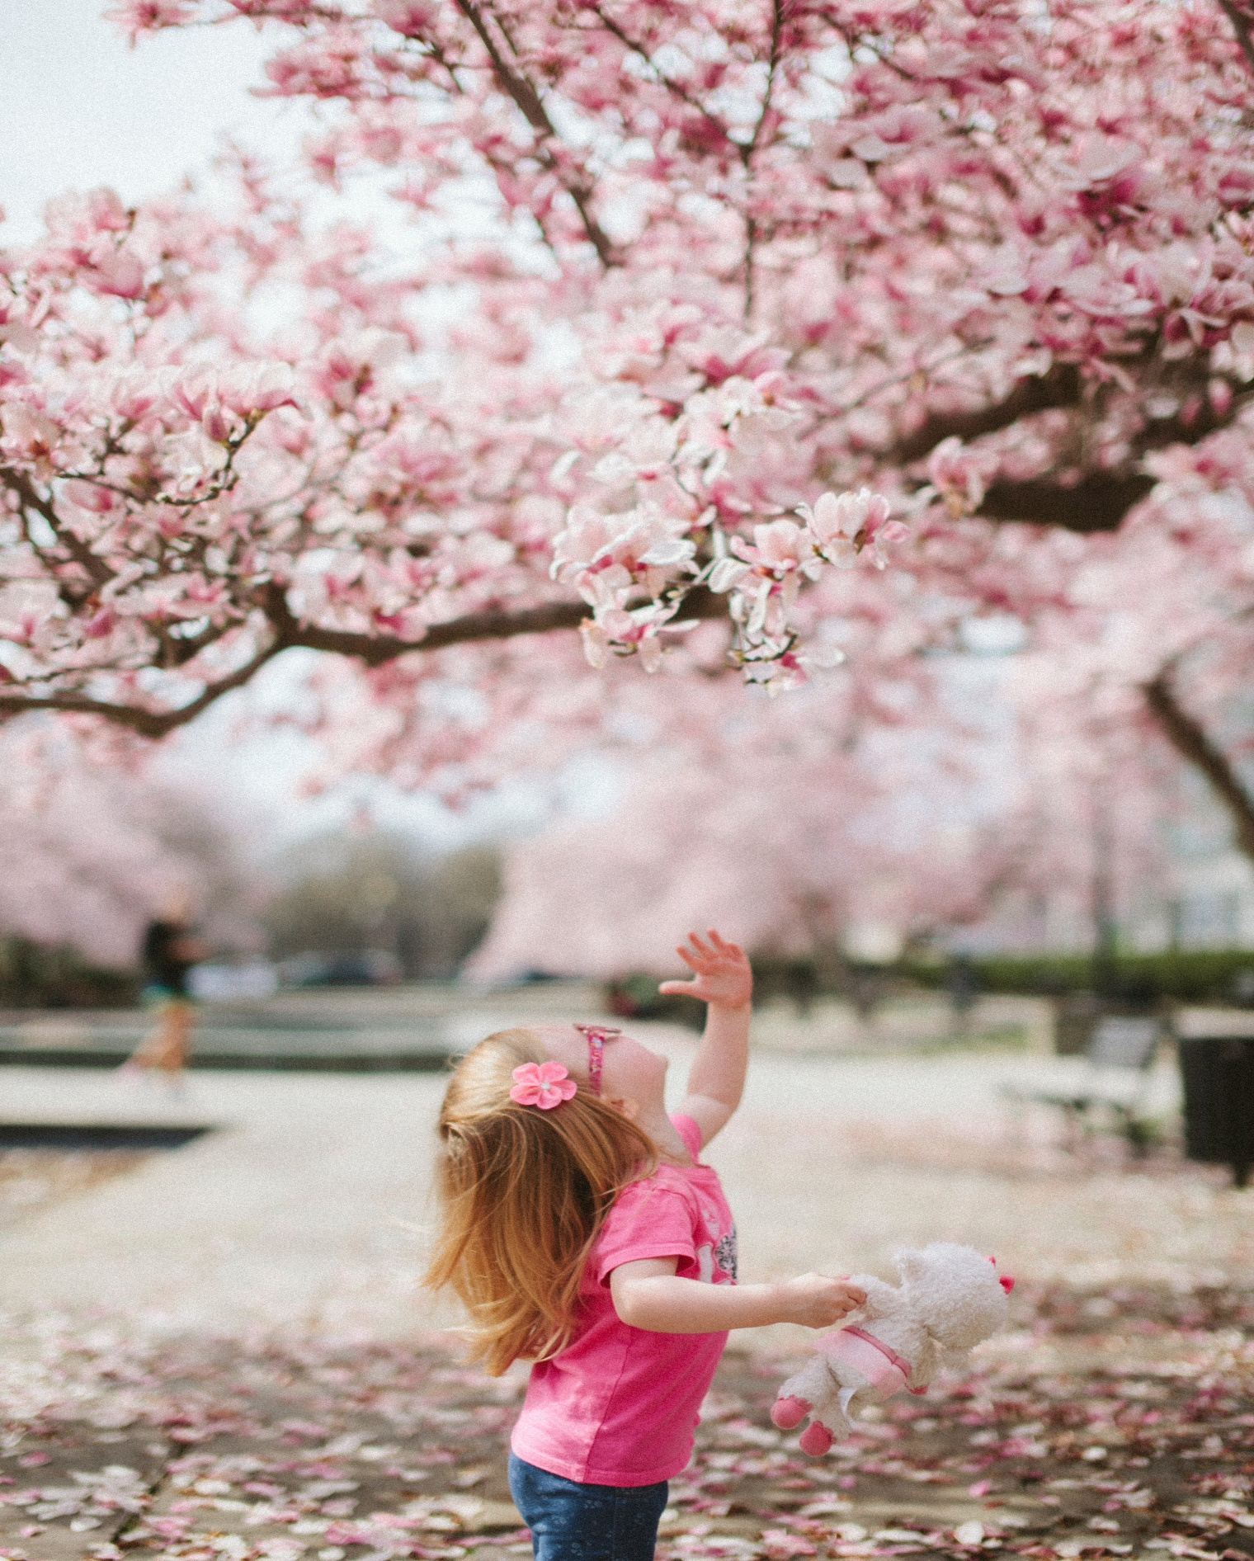

Association Communautaire
CANTERBURY
Community Association
Spring/Summer - 2019 – Printemps/ Été
2185, rue Arch Street, Ottawa, ON K1G 2H5 www.cca-acc.ca

REGISTRATION / INSCRIPTIONS
Register Online / Inscrivez-vous en ligne
www.cca-acc.ca
Online registration opens:
Spring/Summer: February 11, 2019
Début des inscriptions en ligne:
Printemps/Été: 11 Février 2019

CANCELLATIONS/ANNULATIONS
Really great programs get cancelled when you wait until the last moment to register. A decision to cancel a program is made several days prior to program running and a full refund will be issued. You will be notified beforehand if a program is cancelled so do not wait too long to register.

Des excellents programmes sont annulés lorsque vous attendez jusqu’au dernier moment pour vous inscrire. La décision d’annuler est prise plusieurs jours avant le début du programme et vous serez remboursé. Vous serez avisé préalablement si un programme est annulé.

REFUNDS / REMBOURSEMENTS
Pro-rated refunds will be given ONLY if requested at least TWO full business days before the second class in the session. Full refunds will be given if the Association cancels the course. Refunds in the form of a credit note with no cash value will be granted upon request after the second class for medical reasons only and the request must be accompanied by a medical certificate. For one-day or weekend classes or weekend classes, refunds will be given if requested, two business days before the class begins. Please note that no refunds will be given if such action jeopardizes the financial viability of the course as determined by the Program Administrator and the Treasurer. There will be an administrative charge of $10.00 on ALL Refund requests for programs in the current session.

Les remboursements sur une base de prorata seront accordés aux participants qui en font la demande au moins DEUX jours ouvrables avant le début de la deuxième séance de la présente session. Les remboursements complets seront accordés si le cours est annulé par l’Association. Les remboursements sous forme d’une note de crédit (et non en espèces) seront remis après la deuxième séance pour des raisons médicales, seulement si la demande est accompagnée d’un certificat médical. Pour les programmes d’une journée ou d’une fin de semaine, les demandes doivent être présentées deux jours ouvrables avant le début du programme. Veuillez noter que qu’il n’y a pas de remboursement si la retraite du cours met en question sa viabilité financière tel que déterminé par le Directeur des programmes et le Trésorier. Des frais administratifs de 10,00 $ s’appliqueront pour TOUTE demande de remboursement traitée.

Courses

Doodle Dreams ………………………………………………………………………… PAGE 2
Art Attack ………………..………………..………………..…………………………… PAGE 2
Creative Writing ………………..………………..………………..…………………… PAGE 6
Adult Hip-Hop ………………………………………………………………………….. PAGE 7

New
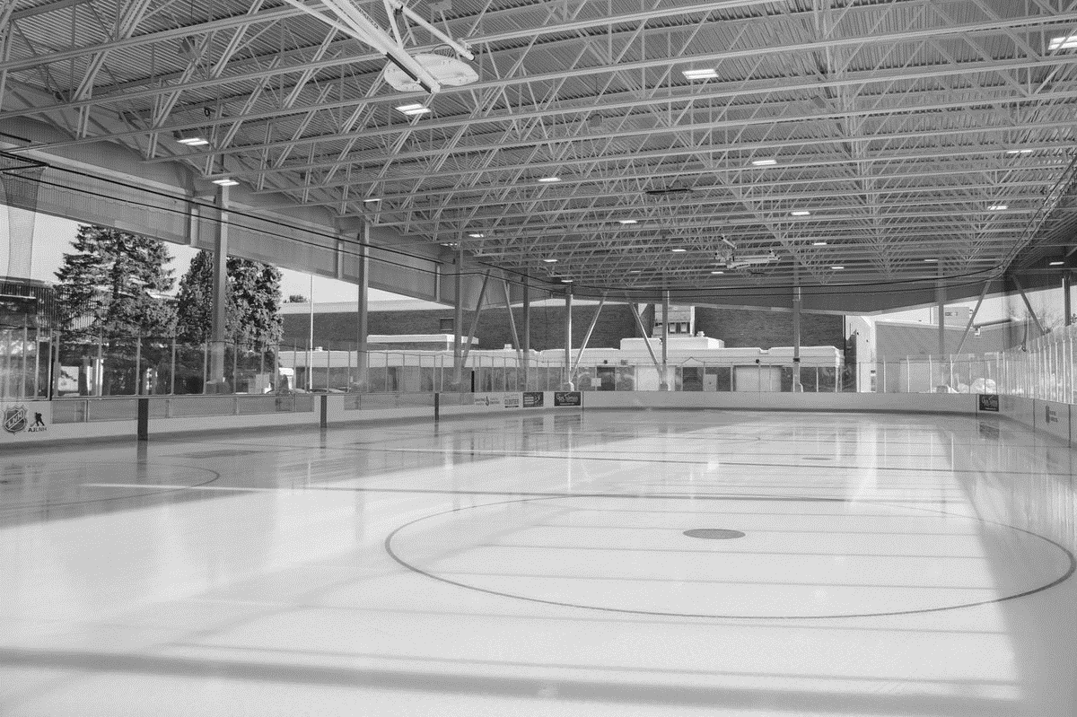

Dear Neighbours, chers voisins,

Welcome to the Canterbury Community Centre. Let this guide be your key to maintaining an active and social lifestyle throughout the spring and summer months. Discover the many programs that nurture your talents and explore your creativity through sport and art. The Canterbury Community Centre offers a wide variety of recreational programs for residents of all ages. Trouvez ici l’activité parfaite pour vous et votre famille.

Thank you for making the Jim Tubman Chevrolet SENS RINK a smashing success. Expect programming here to continue throughout the summer, with more opportunities to play, exercise and socialize. Thank you to the Canterbury Community Association and the staff of the Canterbury Recreation Complex for their help in organizing and maintaining this wonderful new resource for our community.
Notre communauté à fait de la Patinoire Sénateurs Jim Tubman Chevrolet un succès retentissant. Nous allons voir une programmation active se poursuive tout l'été avec davantage occasions pour jouer, faire de l'exercice et socialiser. Merci à l'Association communautaire de Canterbury et au personnel du complexe de loisirs de Canterbury pour leur aide dans l'organisation et le maintien de cette merveilleuse nouvelle ressource pour notre communauté.

As the councillor for Alta Vista ward and your representative at City Hall, I am always available to discuss any municipal issue, and offer support in your community endeavors. Please contact my office at any time – I’d love to hear from you. C’est toujours un plaisir de discuter avec vous. N’hésitez jamais de communiquer avec moi.

Jean Cloutier
Conseiller, Councillor: Alta Vista
613-580-2488
Jean.Cloutier@ottawa.ca
Register for our newsletter at www.JeanCloutier.com!

Facebook.com/JeanCloutierOtt
Twitter.com/AltaVistaWard18
Preschool
Co-operative Playgroups (up to 5 years)
Come join us for a fun morning of play. Our spacious playroom includes climbers, large riding toys, baby toys and a craft every time. So, bring a peanut-free snack and come meet some new friends! Parent/Caregiver participation is mandatory. This is not a drop-in program; you must register for the session.
Tuesday 9:30-11:30am
April 2 – June 18 $38
Thursday 9:30-11:30am
April 4 – June 20 $38
Friday 9:30-11:30am
April 5 – June 21 $38

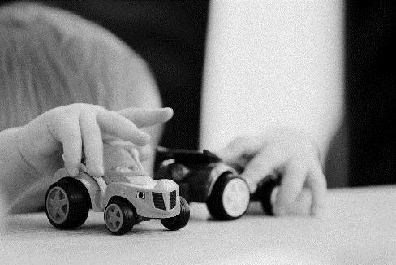

Music Time for Sunrise (2 to 4 years)
Children are introduced to the wonderful world of music through singing, rhythm and listening activities. Teddy friends guide the children in their musical journey. Group instruction enhances development of listening awareness, fine motor skills, attention span, and social skills. Creativity and expression are nurtured in every component of the program. Free for children 22 months and under when accompanied with a registered child.
*Supply fee of $20 payable to instructor on 1st day of class
Level 3 Tues. 10:00-10:45am
April 2 – June 4 $100
Level 1 Tues. 11:00-11:45am
April 2 – June 4 $100

Children
www.cca-acc.ca page 2
ARTS & CULTURE
Musical Theatre (8 to 14 years)
Would you like to express your creativity into three combined art forms? In this musical theatre course, you will learn the fundamentals of acting, singing and dancing! Through this course you will study your role and memorize lines and songs. You will also learn new techniques to emphasize your performance. All lines need to be memorized the week before the show date. To register for the course, the child must be able to read and follow along on their own. Program cost includes $20 costume fee.
Spring Production: The Little Mermaid
Friday 6:45-8:30pm
April 5 – June 21 $95
Open house performance on June 21 2019

Lights, Camera, Action! (6 to 9 years)
Come and get out of your comfort zone and shake out your silly’s! You will study the fundamentals of improvisation through exercises that help to develop strong ensemble and character work. Develop stage presence, patience, good communication skills, self-confidence and a respect for other performers and their creativity. We will focus on storytelling, random scenarios, dance, performance skills and drama games. Come join in on all the fun!
Saturday 11:30-12:15pm
April 6 – June 8 $70

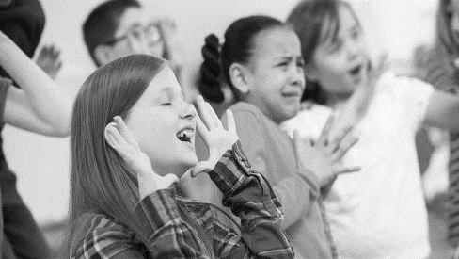

Doodle Dreams (5 to 7 years)
Doodle dreams is a hands-on, informative and imaginative course designed to introduce children 5-7yrs to the wonderful world of visual art. Budding artists will be encouraged to express themselves freely using color, shape, and texture while exploring paint, collage and the exciting ways that everyday items can be used to create beautiful and practical art! Children will also be given tips and tricks to help set-up and maintain an organized "artist space" and learn how to create a quick and easy art portfolio to store favorite pieces. Each week will focus on new concepts through simple but fun exercises, a "first-class" group game so children can get to know each other, meaningful projects, and examples of work from inspiring artists. All that is needed is a curious heart and a desire to create! Supplies and materials provided!
Saturday 10:00-11:00am
April 6 – June 8 $70

Children’s Art Attack (8 to 12 years)
What is the best way to raise our children’s creativity? The answer is trying out as many things as we can! In this art class, children will create various types of art projects using all sorts of materials. From learning the fundamentals drawing to 3-D painting, this 8-week program will enhance creativity and confidence. Guided by an instructor, kid’s will be able to explore and share ideas in a positive space.
Saturday 11:10-12:10pm
April 6 – June 8 $70

No classes on April 19 to 22 and May 18, 20

Children
FITNESS & SPORTS
Yoga Adventures for Kids! (4 to 6 years)
Come and join us Saturday afternoon for yoga with your 4-6 year old. Yoga can be helpful to children in their formative years by increasing their self-awareness, building their self-esteem, and strengthening their bodies. Filled with exciting stories and bursting with fantastic creatures and movements, this class will offer the opportunity to cultivate mind-body awareness. Yoga mats will be supplied, but you are welcome to bring your own if you wish. Parent/Caregiver Participation Mandatory.
Saturday 3:30- 4:00pm
April 6 – June 8 $36

Get your Kicks Soccer
This CCA soccer program will allow young children to learn and understand the fundamentals of soccer skills and the basic aspects of game play, such as shooting, passing, and dribbling. In this program we will explore the sport of soccer using active, silly warm-ups and fun skill development drills. Our emphasis will be on having fun in a structured environment, and learning the basics, so come get your kicks!
4-5yrs Sat. 1:00-1:45pm
April 6 – June 8 $70
6-8yrs Sat. 2:00-3:00pm
April 6 – June 8 $70

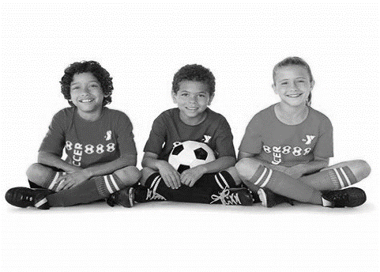

Children
GENERAL INTEREST
Kid’s in the Kitchen
Our chefs will learn a variety of techniques and understand the importance of kitchen safety and personal hygiene. The recipes will consist of simple ingredients, easy to follow instructions, and fun for everyone. Each chef will complete the course with a personal recipe book! You’ll be able to bring home your masterpiece each week (Please bring your own plastic container with a lid for leftovers.)
*Program cost includes supply fee of $20.
Saturday 9:30 – 11:30am
April 6 – June 8 $115

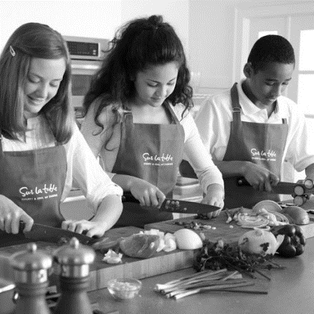

Mindfulness for Kids (7 to 10 years)
Mindfulness is a superpower! Through a series of fun mindfulness activities, children have the opportunity to learn how to improve their self-awareness, self-acceptance, and develop the life skills that will help them to better manage their mind and emotions. Some additional benefits for the child are reduced stress, reduced negative thinking, ability to quiet the mind and stay in present moment awareness, improved focus, improved self-confidence, and improved academic success.
Monday 6:15-7:00pm
April 1 – June 3 $70

Babysitting Course (12+ years)
The Canada Safety Council has designed this course to provide information on babysitting skills and emergency situations. A certificate will be provided upon successful completion of this course.
Sunday 10:45am - 4:00pm
April 7 & April 14 (2 weeks) $79
*Program cost includes Manual
www.cca-acc.ca page 3
Home Alone Course (9+ years)
The Canada Safety Council has designed the Home Alone Program to provide children 9 years and older with the necessary skills and knowledge to be safe and responsible when home alone for short periods of time. It will help them understand how to prevent problems, handle real-life situations, and keep them safe and constructively occupied. The child will learn to follow safety procedures, learn how to obtain emergency help and will review basic first aid procedures.
Sunday 10:45am - 4:00pm May 5 $47
*Program cost includes Manual

Kid’s Dinner & Movie

Hey Parents and Guardians! In need of a night out? Register the kids for our monthly Dinner & Movie where they will enjoy some fun starter games, a pizza dinner with a healthy snack and beverage, and a movie all while you go out and do the same! These nights are staffed by our qualified counsellors of the After School Program.
*Registration in advance mandatory. This is not a Drop-In.
Ages 4 -12
Friday. 5:30-8:30pm
Feb 22
March 29
April 26
May 31
Cost: $15.50/Child

MARTIAL ARTS
The Ouellette Karate & Self-Defense team of Certified Black Belts has over 90 years of combined experience to guide students in achieving their developmental goals. Please note uniforms are not mandatory, they can be purchased directly from the Richard Ouellette School of Karate.
These programs are focused on developing an individual’s physical and mental well-being through this ancient art. Throughout these programs students will build up their confidence, self-esteem, focus, balance and co-ordination, as well as their overall physical fitness level.

Karate for Kids – 5 – 7 years old
A fun, high energy program designed to introduce children to Karate. This introductory program focuses on building strong self-esteem, personal fitness, and fundamentals of self-defense through fun physical activities and continuous positive re-enforcement. Our program prepares young students for participation in the Beginner class. All classes are taught by caring, licensed instructors.
Beginner Karate – 8 - 14 years old
An introductory course that teaches the fundamentals of Karate and Self-Defense to beginners and prepares them for more advanced training. Students will learn stances, blocking, punching, striking and kicking along with safe falling and rolling. Fun and teamwork will be emphasized.
Adult Karate – 15+ years old
This is a comprehensive course that starts with the fundamentals of Karate and Self-Defense. Students will begin learning the basic tools and techniques to defend themselves (stances, blocking, punching, striking, kicking as well as safe falling & rolling). You will learn more advanced techniques such as pressure points, throws, chokes, strangulations, ground work as well as free sparring & apply them to more complex self-defence scenarios. Lastly, students are exposed to weapons such as the two-foot canes, 6-foot-long staff and defending against knife attacks!
Cardio Muay Thai – 15+ years old
Our Muay Thai kickboxing-based program provides fun, positive & challenging full-body cardio workouts that will burn fat, build strength and increase endurance. These high intensity interval classes will also help to relieve stress, provide better eye-hand coordination, and build self-confidence. Techniques such as punches elbows, kicks, and knees on hand pads and kicking shields will be taught so you can learn to deliver powerful fighting combinations.

Karate for Kids
5-7yrs Sat. 11:45-12:30pm
April 6 – June 22 $84.50

Beginner Karate
8-14yrs Mon. 6:00-7:15pm
Thurs. 6:00-7:00pm
Sat. 1:15-2:15pm
April 1 – June 17 $105.50

No classes on April 19 to 22 and May 18, 20

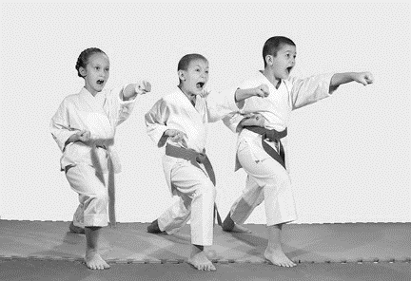
www.cca-acc.ca page 4

Register and Save!
Register for Adult Karate and Cardio Muay Thai for only $192/Session

Adult Karate
15+yrs Mon. 7:20-8:10pm
Thurs. 7:00-8:00pm
Sat 2:15-4:15pm
April 1 – June 17 $110

Cardio Muay Thai
15+yrs Mon. 8:10-9:00pm
Thurs. 8:00-9:00pm
April 1 – June 17 $100

Adult
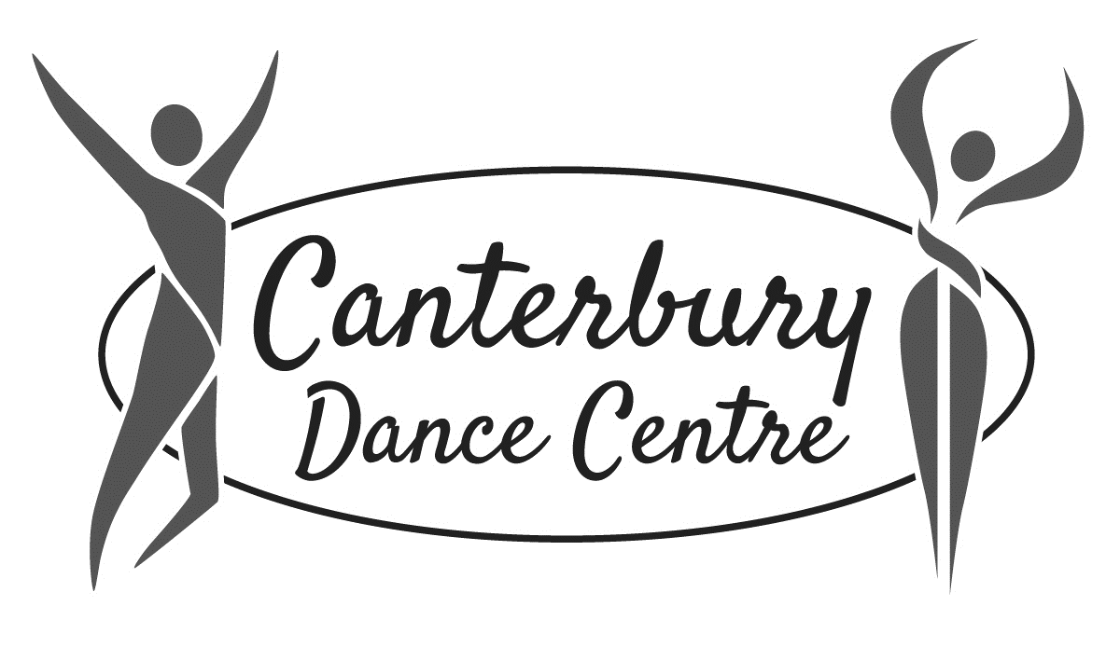The Canterbury Dance Centre offers children of all ages the opportunity to dance in a fun, positive and professional environment. Our recreational dance program is ideal for children to stay fit and to explore their artistic talents in a non-competitive environment. Our qualified, experienced instructors strive to promote self-esteem and positive self-image. Dance styles including Tots & Toes, Jazz, Tap, Ballet, Contemporary, and Hip Hop. The CDC will host an end of year recital in which dancers will either participate in 1 or 2 dances per registered program.
Important Upcoming Dates – Canterbury Dance 2018-2019 Season
Winter/Spring Session | January 7 to May 25
Picture Day | May 26, 2019
Recital Dress Rehearsal | May 30, 2019
Recital | June 1, 2019
NO CLASS | Apr 20, 22, May 18 & 20

The Canterbury Dance Centre is currently in session. Registration for the upcoming 2019-2020 dance year will begin mid-August 2019. Visit our website at www.cca-acc.ca or contact our dance coordinator at dance@cca-acc.ca for more details.

GENERAL INTEREST
Badminton (16+years)
www.cca-acc.ca page 5
Always popular and great fun for the whole family, for couples or singles. This program also includes recreational tournaments. Course takes place at Canterbury High School Gym.
Tuesday 6:30-8:00pm
April 2 – May 28 $50
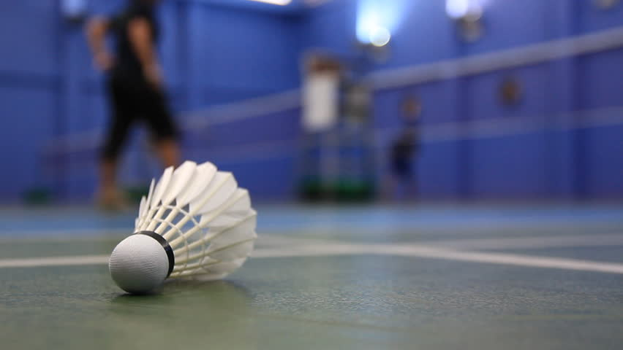

Women’s Self Defense (14+years)
Everyone has the right to be safe. Join Sensei Morgan Duchesney of Okuden Karate Jutsu and Ouellette's Karate to learn practical self-defense and strategies for personal security. In this course you will learn effective methods to either avoid or defeat a variety of physical threats, including sexual assaults and armed attacks that might occur in public, the workplace or even at home. The classes are designed especially for women and teenaged girls seeking self-defense training without the formality of traditional martial arts.
Tuesday 6:05-7:15pm
April 2 – May 21 $60

Morgan Duchesney
During his 22 years of martial arts teaching and research, Sensei Morgan has identified the key principles of personal safety and has developed safe training methods for learners of all ages and abilities.
Instructor Credentials/Ranks:

Karate Jutsu: 5th dan - licensed instructor

Karate Do: 5th dan - licensed instructor
Kenpo Jutsu: 2nd dan - accredited instructor
Police Pressure Point Tactics: Level 1

Contact: morjd@sympatico.ca www.okudenkj.ca

Adult
ART
Drawing Fundamentals (16+ years)
Beginner/Intermediate Level
We will explore the fundamentals of drawing. Discover how line quality, shape, measurement, light logic, and form hold the answer to drawing everything. We will use proven drawing exercises made famous by accomplished art teachers- past & present. Bring your pencils and paper, let’s have some fun!
Tuesday 9:30-11:15am
April 2 – May 21 $121

Colour Theory & Painting- Focus on Watercolour (16+ years) Beginner/Intermediate Level
(Oils & Acrylics welcome)
Mix the colour you want quickly, accurately, and without waste! Painting techniques will be introduced as we practice colour theory in a logical manner using the amazing insights of Michael Wilcox’s “colour bias wheel”. Bring your own supplies, see CCA for list.
Tuesday 11:30am-1:15pm
April 2 – May 21 $121

No classes on April 19 to 22 and May 18 to 20

www.cca-acc.ca page 6

Classical Drawing- Focus on the Human Figure (16+ years)
Intermediate/Advanced
We will learn classical drawing fundamentals with a focus on the human figure including the human head. Discover how understanding light logic, form, measurements, shape and line quality hold the answers to accurate drawing.
Thursday 9:30-11:15am
April 4 – May 23 $121

Watercolour Painting (16+ years)
Intermediate/Advanced
Ideal for those who have watercolor experience, previous artistic training and an understanding of colour mixing. We will be refining or painting skills as we explore various techniques in order to recognize and develop your own unique style.
Thursday 11:30am-1:15pm
June 4 – May 23 $121
Kathy Harker-Fiander (www.kathysartwork.com)
your instructor teaches our Drawing Fundamentals, Colour Theory, Classical Drawing and Watercolour courses.
Bring your own supplies- supply list available online at
www.cca-acc.ca

Creative Writing Workshop (16+ years)
Ottawa authors, aspiring or accomplished, are invited to join a new and exciting creative writing workshop to develop and revise their creative works-in-progress while fostering a supportive writing community. Each week designated participants (on a rotating basis) will share selections from their budding literary works in various writing genres (including but not limited to: creative/narrative nonfiction, fiction, flash fiction, poetry, stage plays, screenplays, essays, articles, etc.) and will be expected to constructively critique the works of fellow participants.
Thursday 7:00–9:00pm
April 4 – June 6 $100

Ikebana (16+ years)
Learn the art of Ikebana, Japanese style flower arranging. Classes are suitable for new and continuing students.
Wednesday 7:00-9:00pm
April 3 – May 22 $89
*Supply fee of $80 payable to instructor on 1st day of class

Adult
MIND & BODY
Mindfulness Meditation (16+ years)
Experience the benefits of a regular meditation practice. This course provides instructions in the basic techniques and theory for meditation and supports you in developing a home practice. Learn to increase your level of self-awareness, self-mastery, gain an overall sense of wellbeing, live a more balanced and harmonious life and maintain optimal health to help you achieve your maximum potential.
Monday 7:15-8:45pm
April 1 – June 3 $100

Qigong (16+ years)
Qi = Energy, Gong = Practice
Pronounced Chi Kung, this is a graceful form of exercise and meditation which energizes, relaxes, and rejuvenates your entire being. It is easy to learn, suitable for all ages and fitness levels, and is performed standing or sitting. Each class includes a warm-up, short meditation, proper breathing, flowing movements, invigorating self-massage, and energy cleansing exercise.
Wednesday 6:30-7:45pm
April 3 – June 5 $102

Tai Chi (Yang Style) – All levels (16+ years)
This great way to improve your blood
circulation, joint flexibility and mobility! Also promotes proper posture and body balance while having a positive mental effect on attentiveness, concentration and memory retention. Students learn the whole Hand Form (108 movements).
Tuesday 5:45-7:00pm
April 2 – June 4 $102

www.cca-acc.ca page 7

Tai Chi (Chen Style) and Qigong
This course is designed for better health, stress relief, relaxation and to keep your body fit and flexible. We learn 24 Tai Chi forms that also encompass Qigong, along with breathing techniques that build internal energy while moving it through the body meridians.
*No Classes Oct 18 2018
Level 1
Thursday 6:30-7:45pm
April 4 – June 6 $102
Level 2
Thursday 7:45-9:00pm
April 4 – June 6 $102

Adult
DANCE
Adult Hip-Hop (18+ years)
Welcome to the world of hip-hop, a combination of jazz and street movement that everyone can enjoy! This adult beginner level course will touch on the fundamentals of movement and hip-hop dancing. Join us in a fun, positive space and groove to rap, pop and r & b music.
Friday 7:00-8:00pm
April 5 – May 31 $87

Ballroom Dancing- 1 & 2 (16+ years)
Learn the basics of ballroom with this class for beginners. Some of the dances include; Cha-Cha, Rumba, Triple Swing, Merengue, Waltz & Foxtrot.
Sunday 1:00-2:00pm
April 7 – June 9 $95/person

Ballroom Dancing- Intermediate (16+ years)
Open to all dancers with knowledge and experience in the basics. Dances include Cha-Cha, Rumba, Waltz, Foxtrot, Swing, Samba and more. In this course, you will learn more figures and more expression of the dances.
Sunday 2:00-3:00pm
April 7 – June 9 $95/person

Argentine Tango- Beginner (16+ years)
Learn Argentina’s signature dance. This class features the salon style of Argentine Tango with focus on connection, leading and following skills as well as musicality. The class has an overview of very basic yet elegant tango that is designed to be fun and easy to dance.
Sunday 3:00-4:00pm
April 7 – June 9 $95/person
Andre Beaulne
your instructor, since 1996 has been teaching all styles of Ballroom Dancing, including International Ballroom & Latin, Swing, Salsa, Rock & Roll and Argentine Tango. He is the Head of Department with the Canadian Dancesport Federation. So, grab a partner and start the party! (www.francineandre.com)

Adult
YOGA
Hatha Yoga (16+ years)
Hatha Yoga improves mental and physical health through relaxation, breathing and stretching. An enjoyable and effective approach to managing stress and improving strength, flexibility, concentration & overall wellness.
Beginner
Wednesday 7:30-9:00pm
April 3 – June 5 $108
Thursday 6:00-7:15pm
April 4 – June 6 $97
Intermediate
Thursday 7:30-9:00pm
April 4 – June 6 $108
Advanced Beginner
Monday 7:30-9:00pm
April 1 – June 17 $108
All Levels
Monday 10:30-noon
April 1 – June 17 $108
Sunday 9:30-11:00am
April 7 – June 23 $108

Absolute Beginner Yoga (16+ years)
Never practiced yoga? This class is designed as an introduction to yoga practice in a supportive environment and is welcoming to the apprehensive student. If you want a gentle way to learn more about yoga, this class is for you.
Thursday 5:30-6:30pm
April 4 – June 6 $92

www.cca-acc.ca page 8

Restorative Yoga (16+ years)
Restorative yoga is a passive, gentle style of yoga using props to support the body for longer holds. Restorative poses are usually held in lying down or seated postures using blankets, bolsters, straps and blocks. It is a relaxing form of yoga which may compliment your active practice and/or lifestyle. As there is limited movement, an extra top layer of clothing is recommended. Please bring a light blanket or two(approx. 80″ x 20″) and an optional eye mask/pillow.
Monday 7:30-8:45pm
April 1 – June 17 $108
Yin Yoga (16+ years)
Yin Yoga targets the deep tissues of the body (ligaments, joints, bones and the deep fascia) by stressing them differently through a variety of poses. Most poses are done on the floor and include the hips, lower body and spine and are usually held 3-5 minutes in calmness and stillness. Some upper body poses may also be incorporated. It is now well known that healthy and strong connective tissues are key to continued vitality and mobility.
Tuesday 10:15-11:30am
April 2 – June 4 $97
Thursday 10:15-11:30am
April 4 – June 6 $97

The Roll Model (16+ years)
This Hatha class will integrate the Roll Model® Method, developed by Jill Miller, to enhance our exploration of asana sequences with an emphasis on sound alignment. Each class will include guided self-massage using therapy balls to awaken muscles, loosen up adhesions, and restore slide and glide to your tissues. We will experiment with the use of props to fine-tune postural practice to your body. Join us to experience this profoundly transformational practice!
Wednesday 6:00-7:15pm
April 3 – June 5 $97

Ashtanga (16+ years)
In this style of yoga, poses are linked together by the breath in continuous, flowing sequences. This is a vigorous, dynamic practice that builds concentration & emphasizes strength in equal proportion to flexibility. Our focus will be on linking movements to breath, good alignment in the postures, and modifications to help develop yourself.
Tuesday 7:00-8:30pm
April 2 – June 4 $108

Kundalini Yoga (16+ years)
Known as the yoga of awareness, this is a meditative yet energizing practice. The key to controlling the mind and strengthening the body is control of the breath.
Tuesday 7:30-9:00pm
April 2 – June 4 $108

Adult
FITNESS
Pilates (16+ years)
This holistic exercise is designed to condition body and mind, help strengthen core muscles, improve posture and increase flexibility. Please note that participants must have completed Beginner Pilates before taking Intermediate/Advanced Pilates
Beginner
Tuesday 8:20-9:15pm
April 2 – June 4 $100
Intermediate/Advanced
Tuesday 7:20-8:15pm
April 2 – June 4 $100

Zumba
This is a cardiovascular workout, combining fun Latino movements with fantastic Latin music. You will have so much fun you’ll forget you’re working out.
16+yrs Fri. 4:30-5:30pm
April 5 – June 28 $100

Special Needs Fitness
This group fitness class is for adults with developmental disabilities. Activities include basic aerobics, circuit-type workouts, core-strength and balance exercises. Participants are encouraged to work at their own pace and must be mobile and able to work at a 1:5 ratio. Assessment of the participants is required prior to the start of the program
16+yrs Sat. 10:45-11:45am
April 6 – June 8 $75

www.cca-acc.ca page 9
50+
Zumba Gold (50+ years)
Dance Fitness uses Latin dancing and international rhythms to provide a safe, fun and effective workout. Moves are broken down in an easy to follow format- you’ll be having so much fun you’ll forget you’re working out! Dance Fitness strives to improve balance, strength, flexibility and aerobic ability. No dance experience or partner required.
Wednesday 9:00-10:00am
April 3 – June 26 $103
Thursday 11:15-12:15pm
April 4 – June 27 $103

Gentle Yoga (50+ years)
Increase flexibility and strengthen through a combination of centering and breathe work, warm-up stretching, gentle hatha postures, and guided relaxation.
Friday 10:15-11:30am
April 5 – June 14 $97

Sit Fitness! (50+ years)
This gentle, yet comprehensive fitness class is designed for the senior participant who wants and needs an alternative to the traditional aerobics class. Through the use of chairs (and walls), exercises will be adapted and modified to both sitting and standing positions. We will tone and strengthen using light hand weights, weighted balls, and elastics. We will stretch to release tight muscles and joints and will improve flexibility and range of motion. The class will also focus on improving posture, balance, and overall coordination. Learn to breath more deeply, stand a little taller and move through your day with greater confidence and ease. Instructor: Nancy Burns-Horler
Monday 1:00-2:00pm
April 1 – June 17 $73
*No Class May 20 2019
Wednesday 1:00-2:00pm
April 3 – June 12 $73
*No class May 22 2019
Register and Save!
Register for both Monday and Wednesday Sit Fitness for only $126/Session

www.cca-acc.ca page 10
50+ ENERGY
GROUP FITNESS PROGRAM

Do you want to have more energy, feel stronger and be able to navigate daily life with a sense of physical confidence and greater ease? The physical and social benefits associated with regular group physical activity are well documented. Join us and discover how our program can improve your life and general sense of well-being!
Our sessional pass enables you to attend any class in the ENERGY PLUS schedule, thereby customizing a program suitable to your physical abilities and preferences.

50+ Coordinator: Nancy Burns- Horler
Spring Session Date: April 1 – June 28 Spring Session Pass: $107
Monday | Tuesday | Wednesday | Thursday | Friday
9:00-10:00am  Cardio Mix*  (Advanced) | 10:15-11:15am  Aerobics | 9:00-10:00am  Zumba Gold | 10:15-11:05am  Aerobics | 9:00-10:15am  Cardio Mix & Strength*  (Advanced)
10:15-11:05am  Aerobics | 1:00-2:00pm  All Stretch | 10:00-10:45am  All Stretch | 11:15-12:15pm  Zumba Gold  (All Levels) | 10:30-11:30am  Friday Variety
11:15-12:05pm  MSE & Ball |  | 10:15-11:15am  Aerobics

Cardio Mix (Advanced): These classes are for the more experienced participant and will vary in format from week to week with the main emphasis on cardio. Weights, stability balls, bands and body bars will be incorporated. Step aerobics will be incorporated on alternate Fridays.
Aerobics: These classes will be taught in a multi-level fashion. Exercise options will be given to those who wish to work at a higher (or lower) intensity. Classes will consist approximately 15-20 minutes of aerobic conditioning with a segment of muscle toning, core conditioning, and balance training.
MSE & Ball: This is a muscle strength and endurance workout using weights and stability balls. The ball is used to improve balance, posture, coordination, strength and endurance. If you want stronger abdominal and back muscles, this is the class for you.
All Stretch: Strength and flexibility go hand in hand. This class is dedicated to improving flexibility, releasing stress and developing better posture and body awareness.
Zumba Gold: Dance Fitness uses Latin dancing and international rhythms to provide a safe, fun and effective workout. Moves are broken down in an easy to follow format- you’ll be having so much fun you’ll forget you’re working out! Dance Fitness strives to improve balance, strength, flexibility and aerobic ability. No dance experience or partner required.
Friday Variety: This beginner level class is suited for beginners or for those wishing for a lighter workout at the end of the week. The class format will change from week to week to provide a “variety” of workouts. A schedule of classes will available at registration.

*Although intensity options will be given in all classes, the 9:00AM advanced courses on Monday & Friday are geared specifically to the advanced participant. The cardio segment of these classes will be longer in duration and more advanced in intensity and complexity.
Please note that classes will be cancelled on April 19, 22 and May 20
It is recommended that participants check with their doctor before participating in any exercise program,
and checking again after a change in the participants’ health status.

www.cca-acc.ca page 11
ADULT
GROUP FITNESS PROGRAM

The CCA’s group fitness program includes a variety of well-balanced classes including Muscle-Strength, Core-Strength, Cardio, Step, Ball and Balance & Flexibility. Our team of instructors love what they do and will help you achieve your fitness goals!
Spring Session Date: April 1 – June 28 Spring Session Pass: $125
10 Visit Pass (Year-Long) $90
Monday | Tuesday | Wednesday | Thursday | Friday | Saturday | Sunday
9:00-10:00am  Cardio Mix | 9:00-10:00am  Strength Mix | 9:00-10:00am  Tabata for Everyone | 9:00-10:00am  Tri Fit | 9:00-10:00am  Strength & Stretch | 9:00-10:30am  Weekend Variety | 9:30-11:00am  Hatha Yoga
 | 10:15-11:30am  Yin Yoga | 10:00-10:45am  All Stretch | 10:15-11:30am  Yin Yoga
6:10-7:10pm  Cardio &Muscle Variety | 6:10-7:10pm  Tabata for Everyone | 6:10-7:10pm  Body Fit | 6:10-7:10pm  Tri Fit | 4:30-5:30pm  Zumba
8:10-9:00pm  Cardio Muay Thai |  |  | 8:00-9:00pm  Cardio Muay Thai
Class Descriptions:
Low Impact: A low impact workout offering higher intensity and cardio options.
Total Body Fit: This full-body workout will combine cardio, strength and core work. Dynamic, full-body movements are paired with isolation exercises focusing on one muscle group. Special emphasis on the core, including back, hips, glutes and abs.
Tabata for Everyone: A very effective workout combining cardio and muscle conditioning in a shorter 45-minute class. The format consists of 8 rounds of one exercise in a 20-second on and 10-second off interval.
All Stretch: Did you know strength and flexibility go hand in hand? This class is dedicated to improving flexibility, releasing stress and developing better posture and body awareness.
Strength Mix: A complete workout to strengthen and tone all muscle groups while improving balance using a variety of equipment.
Tri Fit: Dynamic, fast-paced class that includes cardio, strength and flexibility training. This class includes a step portion.
Strength & Stretch: Functional strength class training with integrated stretch component.
Cardio & Muscle Variety: Each week will be different. Class could include step, low impact and weight training.
Cardio Muay Thai: Our Muay Thai kickboxing-based program provides fun, positive & challenging full-body cardio workouts that will burn fat, build strength and increase endurance. These high intensity interval classes will also help to relieve stress, provide better eye-hand coordination, and build self-confidence. Techniques such as punches elbows, kicks, and knees on hand pads and kicking shields will be taught so you can learn to deliver powerful fighting combinations.
**Cancellations: April 19, 20, 21, 22 and May 18, 19, 20

Canterbury Community Association SUMMER 2019 Programs

Pilates Intermediate (16+ years)
This holistic exercise is designed to condition body and mind, help strengthen core muscles, improve posture and increase flexibility. Please note that participants must have completed Beginner Pilates before taking Intermediate/Advanced Pilates
Tuesday 7:20-8:15pm July 2 – Aug 6 $52

Hatha Yoga – All Levels (16+ years)
Hatha Yoga improves mental and physical health through relaxation, breathing and stretching. An enjoyable and effective approach to managing stress and improving strength, flexibility, concentration & overall wellness.
Thursday 7:20-8:15pm July 4 – Aug 22 $73

Martial Arts
These programs are focused on developing an individual’s physical and mental well-being through this ancient art. Throughout these programs’ students will build up their confidence, self-esteem, focus, balance and co-ordination, as well as their overall physical fitness level. Session Dates: July 4 – Aug 22
Child/Teen Karate (8 to 16 years) Thurs. 6:00 – 7:00pm $63
Adult Karate (16+ years) Thurs. 7:00 – 8:00pm $68
Cardio Muay Thai (16+ years) Thurs. 8:00 – 9:00pm $68

Sit Fitness! (50+ years)
This gentle, yet comprehensive fitness class is designed for the senior participant who wants and needs an alternative to the traditional aerobics class. Through the use of chairs (and walls), exercises will be adapted and modified to both sitting and standing positions. We will tone and strengthen using light hand weights, weighted balls, and elastics. We will stretch to release tight muscles and joints and will improve flexibility and range of motion. The class will also focus on improving posture, balance, and overall coordination. Learn to breath more deeply, stand a little taller and move through your day with greater confidence and ease. Instructor: Nancy Burns-Horler
Wednesday 1:00-2:00pm July 10 – Aug 14 $45

Zumba Gold (50+ years)
Dance Fitness uses Latin dancing and international rhythms to provide a safe, fun and effective workout. Moves are broken down in an easy to follow format- you’ll be having so much fun you’ll forget you’re working out! Dance Fitness strives to improve balance, strength, flexibility and aerobic ability. No dance experience or partner required.
Wednesday 9:00-10:00am July 3 – Aug 21 $82

www.cca-acc.ca page 12

No classes on August 5, 2019

Summer Fitness Schedules
Adult Group Fitness Session Dates: July 2 – Aug 23 Session Cost: $64
Monday | Tuesday | Wednesday | Thursday | Friday
8:30 – 9 :30am  Low Interval |  | 8:30 – 9 :30am  Tabata for Everyone |  | 8:30 – 9 :30am  Strength & Stretch
6:00 – 7 :00pm  Cardio Muscle Variety | 6:00 – 7 :00pm  Tabata for Everyone |  | 6:00 – 7 :00pm  Cardio Combo & Abs
Class Description
Low Interval: Alternates between cardio and strength for a challenging workout.
Tabata for Everyone: A very effective workout combining cardio and muscle conditioning in a shorter 45-minute class. The format consists of 8 rounds of one exercise in a 20-second on and 10-second off interval. Includes 6 exercises that change each week to keep it fun and fresh.
Strength & Stretch: Functional strength class training with integrated stretch component.
Cardio & Muscle Variety: Each week will be different. Class could include step, low impact and weight training.
Cardo Combo & Abs: This class offers various levels of cardio intensity and includes a step portion. This class finishes with a longer abs and back segment.

Energy Plus Group Fitness Session Dates: July 2 – Aug 23 Session Cost: $58
Monday | Wednesday | Friday
9:45 – 10:45am  Cardio Mix (All Levels) | 9:45 – 10:45am  Cardio Mix (All Levels) | 9:45 – 10:45am  Zumba Gold
11:00am – 12:00pm  Muscle Toning (All Levels) | 11:00am – 12:00pm  Stretch
Class Description
Cardio Mix (All levels): This class will be different from week to week, with the main emphasis on cardio. It will include low impact, step circuit, aerobics, and a low and tone. You will get a cardiovascular workout every class. We’ll also use weights, stability balls, bands and body bars. Come prepared to sweat and challenge yourself. Exercise options will be given to those who wish to work at a higher (or lower) intensity.
All Stretch: Did you know strength and flexibility go hand in hand? This class is dedicated to improve flexibility releasing stress and developing better posture and body awareness.

www.cca-acc.ca page 13

Canterbury Recreation Complex
SUMMER CAMPS
Fun'n Friends Energy
Creative play, songs, crafts, themes, and cooperative games offer activities and fun for making friends in your neighbourhood. Campers must be fully toilet trained to attend this camp.
4-5 years Mon.-Fri. 8 am-5 pm
Jun 24-28 $185.75 1428872
Jul 2- 5 $148.75 1428883
Jul 8-12 $185.75 1428873
Jul 15-19 $185.75 1428875
Jul 22-26 $185.75 1428877
Jul 29-Aug 2 $185.75 1428878
Aug 6- 9 $148.75 1428885
Aug 12-16 $185.75 1428879
Aug 19-23 $185.75 1428880
Aug 26-30 $185.75 1428882

Arts Camp
Explore dance, drama, visual arts, or music. Art instruction daily, complemented by camp activities.
6-12 years Mon.-Fri. 8 am-5 pm
Jul 2- 5 $148.75 1428914
Jul 8-12 $185.75 1428909
Jul 22-26 $185.75 1428911
Jul 29-Aug 2 $185.75 1428912
Aug 6- 9 $148.75 1428916
Aug 19-23 $185.75 1428913

Babysitter's Camp
Are you looking forward to your first job? Is babysitting up your alley? We will help give you the skills required to be hired. Includes half-day instruction and regular camp activities.
12-14 years Mon.-Thu. 8 am-5 pm
Jul 15-18 $140.25 1428954
Aug 12-15 $140.25 1428955
What better qualification to have
as a babysitter than your …
LifeSaving Standard First Aid & CPR-Level C with AED
12-14 years Fri. & Sat. 8 am-5 pm
Jul 19 & 20 $122.50 1428950
Aug 16 & 17 $122.50 1428951
15+ years Fri. & Sat. 8 am-5 pm
Jul 19 & 20 $138.50 1428949
Aug 16 & 17 $138.50 1428952

Basketball Camp
Practice the fundamentals of basketball including ball handling, shooting, lay ups, offence and defence, all in an innovative and exciting atmosphere.
8-12 years Mon.-Fri. 8 am-5 pm
Jul 15-19 $185.75 1428900
Aug 6- 9 $148.75 1428902

Chef Adventure Camp
Get ready for a sweet and savory week filled with slice'n and dice'n. Includes daily camp activities and one out-trip throughout the week. Weekly menus should be available and planned by early June. All cooking will be nut-free.
6-7 years Mon.-Fri. 8 am-5 pm
Jul 2- 5 $157.25 1428929
Jul 15-19 $196.50 1428923
Jul 29-Aug 2 $196.50 1428926
Aug 12-16 $196.50 1428927

8-12 years Mon.-Fri. 8 am-5 pm
Jul 8-12 $196.50 1428920
Jul 22-26 $196.50 1428924
Aug 6- 9 $157.25 1428930
Aug 19-23 $196.50 1428928

Ottawa Adventure
Bring all your energy to camp for days of adventure and making friends. Sports, games, crafts, special events and of course, an out trip! (Out trip may include swimming).
6-7 years Tue.-Fri. 8 am-5 pm
Jul 2- 5 $140.25 1428866
Aug 6- 9 $140.25 1428867

8-12 years Tue.-Fri. 8 am-5 pm
Jul 2- 5 $140.25 1428868
Aug 6- 9 $140.25 1428869

Sports Camp
Skills, drills and strategies! Enjoy action- packed days full of your favorite sports and recreational activities.
8-12 years Mon.-Fri. 8 am-5 pm
Jul 2- 5 $148.75 1428896
Jul 22-26 $185.75 1428891
Aug 12-16 $185.75 1428893

Ottawa Adventure Plus
Bring all your energy to camp for days of adventure and making friends. Sports, games, crafts, special events and two out trips! (Out trips may include swimming)
6-12 years Mon.-Fri. 8 am-5 pm
Jun 24-28 $196.50 1428847
Aug 26-30 $196.50 1428848

6-7 years Mon.-Fri. 8 am-5 pm
Jul 8-12 $196.50 1428850
Jul 15-19 $196.50 1428851
Jul 22-26 $196.50 1428852
Jul 29-Aug 2 $196.50 1428853
Aug 12-16 $196.50 1428854
Aug 19-23 $196.50 1428855

8-12 years Mon.-Fri. 8 am-5 pm
Jul 8-12 $196.50 1428856
Jul 15-19 $196.50 1428857
Jul 22-26 $196.50 1428858
Jul 29-Aug 2 $196.50 1428859
Aug 12-16 $196.50 1428861
Aug 19-23 $196.50 1428862

Science Camp Adventure
Hands-on messy fun will allow you to explore your inner scientist through games, crafts and experiments! Science isn't only for adults! Camp activities may include special guest or outing.
6-7 years Mon.-Fri. 8 am-5 pm
Jul 8-12 $175.25 1428931
Jul 22-26 $175.25 1428933
Aug 6- 9 $140.25 1428938
Aug 19-23 $175.25 1428936

8-12 years Mon.-Fri. 8 am-5 pm
Jul 15-19 $175.25 1428932
Jul 29-Aug 2 $175.25 1428934
Aug 12-16 $175.25 1428935

Soccer Camp
Practice the fundamentals of soccer including dribbling, passing, shooting, ball control, goal keeping, heading and various strategies. Camp activities included.
8-12 years Mon.-Fri. 8 am-5 pm
Summer camp hours:
Drop off: 8-9am
Pick up: 4-5pm
A late fee will apply to any pick-ups after 5pm.

Jul 8-12 $185.75 1428904
Jul 29-Aug 2 $185.75 1428906
Aug 19-23 $185.75 1428905

Canterbury Recreation Complex
SUMMER CAMPS
REGISTRATION
In person: Any City of Ottawa recreation centre during regular business hours starting March 7, 2019
Online: www.ottawa.ca/recreation You will need your family PIN number and Client Barcode(s) starting March 6, 2019 at 9pm
By Telephone: 613-580-2588 You will need your family PIN number and Client Barcode(s).

ENROLMENT FORMS must be completed in order to attend camp. An electronic copy of the form can be found at www.ottawa.ca/summercamp. Please submit 1 per child before the beginning of camp

MEDICAL FORMS are required for children with epipen allergies or asthma, who require medication to be administered during camp hours. Please also note any medication taken at home on the enrolment form. Children are to come to camp with two epipens daily. Forms can be found online at www.ottawa.ca/summercamp, or a hard copy can be provided to you at Community Centre or Pool front desks.

For more information on the City of Ottawa Summer Camps offered at Canterbury Recreation Complex,
please call 613-247-4869 or email Canterbury@ottawa.ca
CAMPS AT A GLANCE
 | 4-5 yrs | 6-7 yrs | 8-12 yrs | 12-14 yrs | Out-trip or guest
Fun’n Friends Energy | ✓
Arts |  | ✓ | ✓
Babysitter’s |  |  |  | ✓
Basketball |  |  | ✓
Chef Adventure |  | ✓ | ✓ |  | ✓
Ottawa Adventure |  | ✓ | ✓ |  | ✓
Ottawa Adventure Plus |  | ✓ | ✓ |  | ✓ (2)
Science Adventure |  | ✓ | ✓ |  | ✓
Soccer |  |  | ✓
Sports |  |  | ✓

Where did the Swimming go?!  Do you miss the swimming aspect  of our summer camps already?  We do too!  While we will still be making use of the Splash Pad  and Wading Pool, and some of our ‘Adventures’  will take the kids to other pools/beaches in the City,  Canterbury Pool will be closed for the Summer.  Our ‘&Swim’ camps as well as Swim Explorer camps  will return Summer 2020!  Summer camp hours  Drop off: 8-9am  Pick up: 4-5pm  A late fee will apply for any pick-ups  occurring after 5pm | Pizza Day Friday!  2 slices of cheese pizza, apple juice and your choice of  granola bar or apple sauce  $7 (tax incl.)  *children are still required to bring their own snacks for the morning and afternoon  MUST REGISTER BEFORE THURSDAY @ 5pm
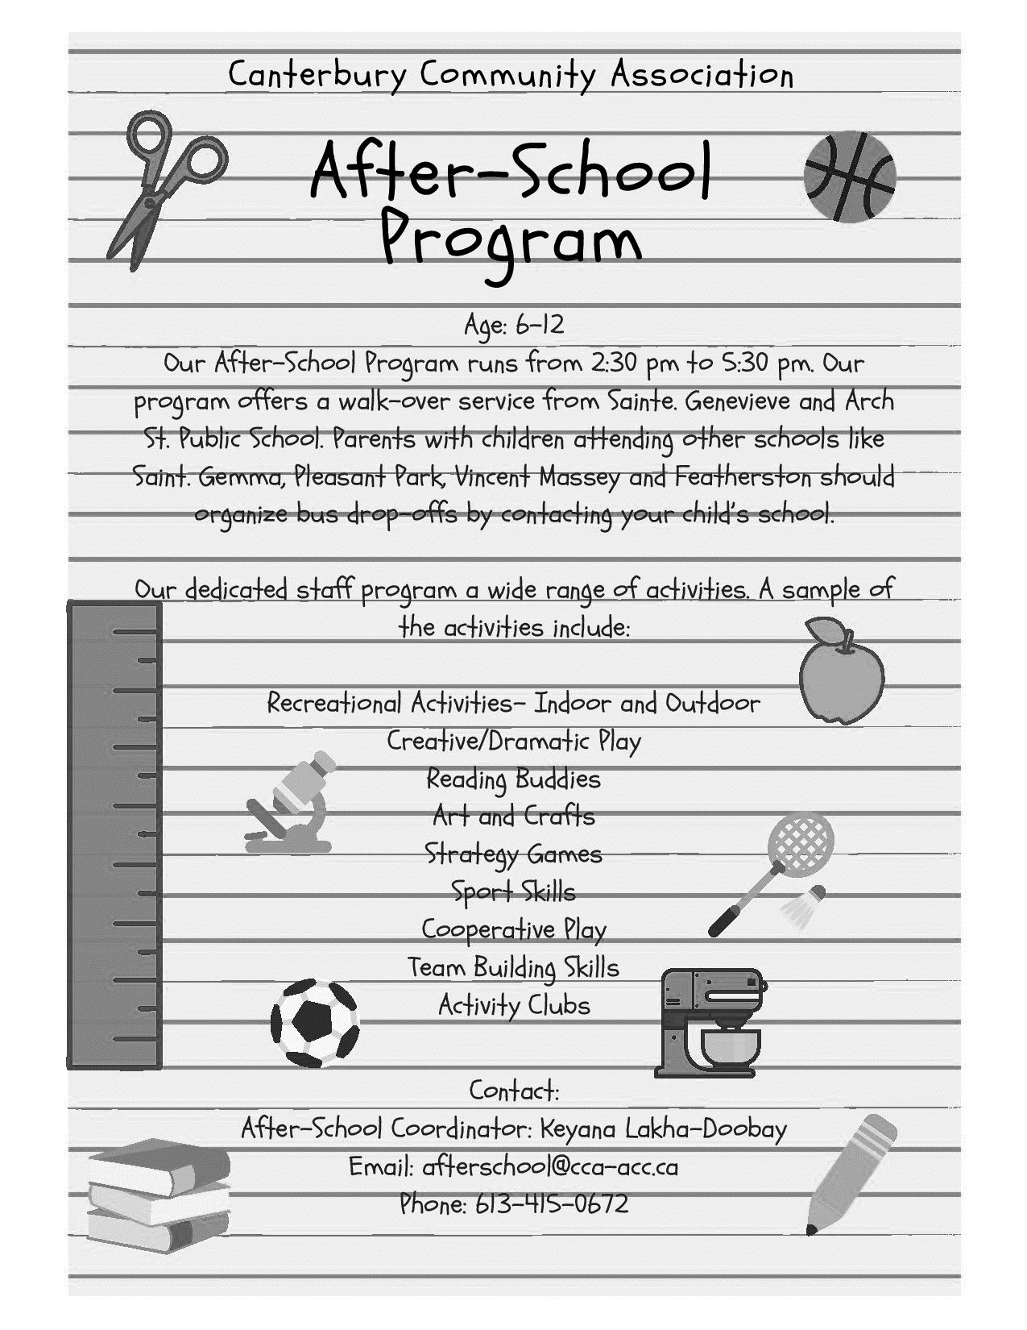

h

MAKE THE RIGHT CALL!
Did you know that we are two entities working cohesively under one roof?
In order to save you time, please ensure you are calling the right phone number.
Canterbury Community Association (CCA): |  | City of Ottawa:
CCA Program Information  CCA After School Coordinator | 613-738-8998  613-415-0672 | Canterbury CC Front Desk & Brian Kilrea Arena  Canterbury CC Rentals  Canterbury Pool | 613-247-4869  613-247-4870  613-247-4865

